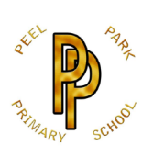 | Peel Park Primary School  Spring Term 2026 Year 2 Curriculum Information

Learning in Year 2 this term:

English | 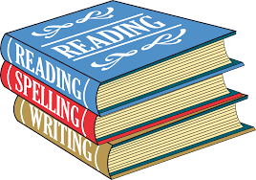 | Whole School Literacy = Winter Poetry  Text = The Colour Monster goes to School by Anna Llenas  Our purpose = Writing to inform, writing a letter, writing a recount.  Text = Here We Are by Oliver Jeffers  Our purpose = Writing to entertain, setting descriptions and writing to persuade(leaflet)
Maths | 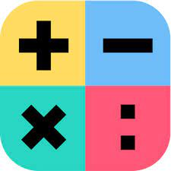 | Shape  Measurement – Money  Number – Multiplication and Division
Science | 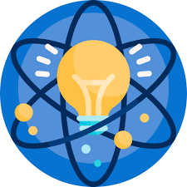 | What do we use different materials for?  Do all plants grow in the same conditions?
Computing |  | E-Safety and Programming – Robot algorithms  Data and information - Pictograms
History | 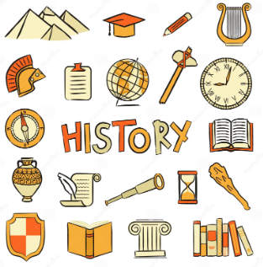 | What was school like in the past?  Victorian Day
Geography | 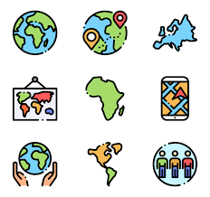 | Why is our world wonderful?
Art | 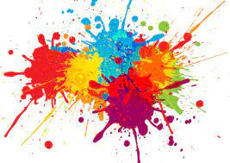 | Painting and mixed media – Life in Colour  Artist – Romare Bearden
DT |  | Mechanisms – Making a moving story book
PE | 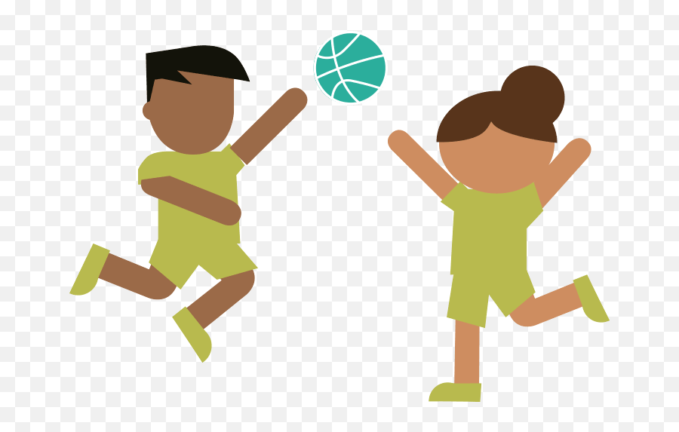 | Dance – Performance  Kicking
PSHE | 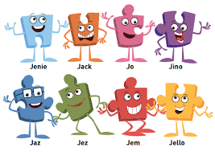 | Dreams and Goals  Healthy Me
Religion and World Views |  | What is a prophet?
Music | 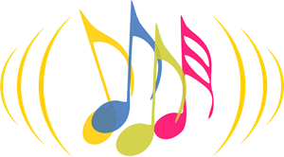 | Instruments – Musical Storytelling
Reading | 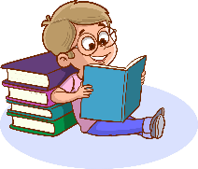 | Your child will read to an adult at least once per week on the same day, this is when the home readers will be changed. Please read with your child 3 times a week and sign their reading record.
Homework | 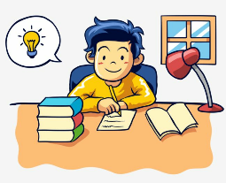 | Homework will continue to alternate between Maths and English. Homework is an activity to do together.

