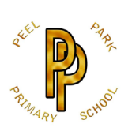 | Peel Park Primary School  Spring Term 2026 Year 5 Curriculum Information

Learning in Year 5 this term:

English | 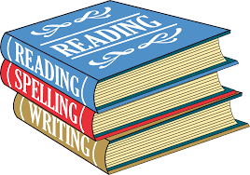 | For Spring 1, we will begin the year with a whole school writing week with a Winter Poetry theme. The children will be writing their own poems using personification. Later, we will be reading the text ‘Treason’ by Berlie Doherty. Children will be writing a narrative and a newspaper report based on their reading. In Spring 2, our focus text is ‘Song of the Dolphin Boy’ by Elizabeth Laird. The children will be writing a diary entry and a narrative inspired by the text.
Maths | 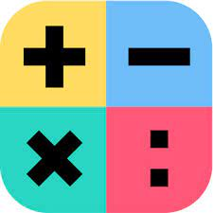 | For Spring 1, we will be focussing on multiplication and division, fractions, decimals and percentages. Children will be introduced to written methods to multiply up to 4-digit numbers by 2-digit numbers and divide up to 4-digit numbers by 1-digit numbers, before learning how to multiply fractions and convert between fractions, decimals and percentages. In Spring 2, we will continue with decimals and percentages before exploring perimeter and area and finishing with geometry (statistic).
Science |  | In Spring 1 we will be exploring materials, seeking to answer the question ‘What are effective materials to use for insulation and conduction?’. In the final 2 weeks of Spring 1, we will investigate how lifecycles differ.  In Spring 2, we will be researching changes that occur as we age.
Computing |  | In Spring 1, the children will look at programming, using Crumble kits to programme circuits. We will then have a focus week on E-safety. In Spring 2, they will explore data and information and look at flat-file databases.
History |  | Our History unit will be taught in Spring 1, exploring the Tudors and seeking to answer the question ‘What was life like in Tudor England?’.
Geography | 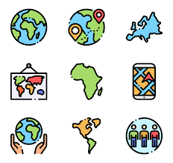 | Our Geography unit will be taught in Spring 2, exploring oceans and seeking to answer the question ‘Why do oceans matter?’.
Art | 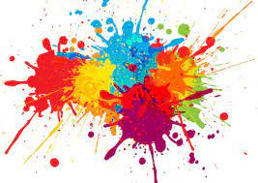 | Art will be taught in Spring 1 of this term. Our topic for art is painting and mixed media. The children will explore a variety of portraits by various artists.
DT |  | DT will be taught in Spring 2 of this term. The children will be learning about structures and making bridges.
PE |  | In Spring 1, the children will have the opportunity to take part in a dance unit with an instructor, following the theme Heroes and Villains. In outdoor PE, the children will be orienteering.  In Spring 2, the children will take part in creative games and tennis.
PSHE | 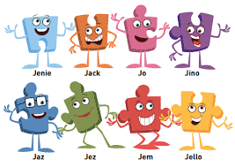 | In Spring 1, our topic is ‘Dreams and Goals.’ Children will discuss their dreams and aspirations, learning how to achieve goals and understanding the emotions that go with this.  In Spring 2, our topic is ‘Healthy me’. The children will learn about being and keeping safe and healthy.
Religion and Worldviews | 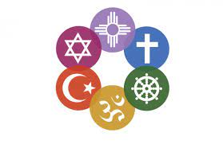 | RE will be taught in Spring 1 of this term. The children will be exploring the question ‘Why doesn’t Christianity always look the same?’
Music |  | Music will be taught in Spring 1 of this term. Children will be taking part in a unit based on looping and mixing.
French | 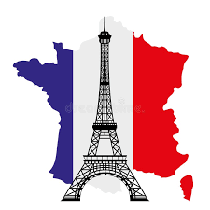 | French will be taught in Spring 2 of this term. In French the children will be learning about French verbs, using them to write their own French week.

