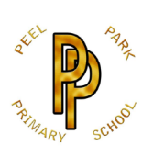 | Peel Park Primary School  Spring Term 2026 Year 6 Curriculum Information

Learning in Year 6 this term:

English | 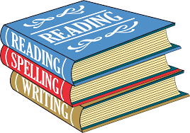 | During Spring 1, pupils will begin with a Winter Poetry theme, developing their understanding of language, imagery, and poetic techniques. This will be followed by the novel ‘Making More Noise,’ where pupils will delve into the lives and impact of influential figures. In Spring 2, pupils will study Pig Heart Boy by Malorie Blackman, using the text to explore ethical issues and character perspectives, alongside developing their ability to write persuasively and construct balanced arguments.
Maths | 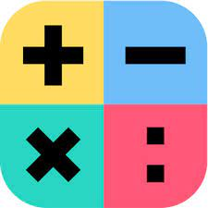 | In Spring 1, children will focus on developing their understanding of ratio and algebra before moving on to fractions, decimals, and percentages. This will help strengthen their reasoning and problem-solving skills across a range of mathematical contexts. During Spring 2, children will study measurement, with a particular focus on area and perimeter, before concluding the term with statistics, where they will learn to interpret and represent data accurately.
Science |  | In Science, children will explore the question ‘How do we see?’ by learning about light, vision, and how the eyes work. Through a range of practical investigations and experiments, pupils will develop their scientific enquiry skills, make observations, and draw conclusions based on evidence.
Computing |  | In Computing, children will develop their programming skills by learning how to use variables within games, enabling them to create and modify interactive programs. Alongside this, pupils will focus on E-Safety, developing an understanding of how to stay safe, responsible, and respectful when using technology and the internet.
History |  | During Spring 1, children will explore the question “Who should go on a £10 bank note?”, linking with their English studies. They will investigate the lives of significant historical figures, examining their impact and why certain individuals are chosen to be commemorated. This unit will develop pupils’ understanding of historical significance, chronology, and the ways in which history is represented.
Geography | 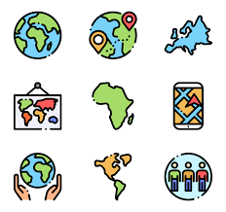 | In Spring 2, children will explore the question “Where does our energy come from?”, investigating the different types of energy sources and how they are used around the world. This unit will help pupils make connections between energy production and their everyday lives, while developing their understanding of environmental impact, sustainability, and geographical enquiry skills.
Art | 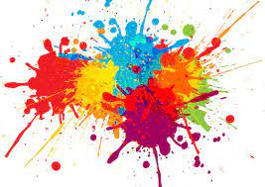 | In Art, children will focus on Painting and Mixed Media, beginning with an artist study to explore different styles, techniques, and creative approaches. They will then develop their own work inspired by artists of personal interest, experimenting with materials and media to express their ideas and build confidence in their artistic skills.
DT |  | In DT, children will focus on structures, designing and building their own playground models. They will explore the properties of different materials, learn how to create stable and functional designs, and develop practical skills in planning, constructing, and evaluating their work.
PE |  | In Spring 1, children will perform a dance routine inspired by villains and heroes, with Year 6 creating their own class performances using a range of dance skills and techniques. During Spring 2, the focus will shift to gymnastics and athletics, where pupils will develop their strength, coordination, flexibility, and overall physical fitness through practical activities and challenges.
PSHE | 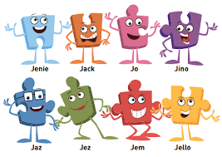 | In PSHE, children will focus on Dreams and Goals, exploring their aspirations, personal strengths, and the steps needed to achieve them. Pupils will learn about setting realistic goals, overcoming challenges, and developing resilience, motivation, and teamwork skills to help them succeed both inside and outside the classroom.
Religion and Worldviews | 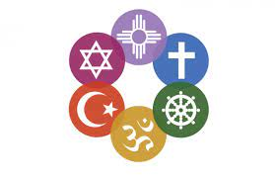 | In Religion & Worldviews, children will explore the question “Why is it better to be there in person?”, considering the significance of presence in religious and cultural practices. Pupils will reflect on different beliefs and traditions, discussing how personal experiences and engagement can shape understanding, respect, and appreciation of diverse worldviews.
Music |  | In Music, children will focus on Theme and Variations, exploring how a musical theme can be developed and adapted through changes in melody, rhythm, and dynamics. Pupils will listen to, analyse, and perform variations, developing their understanding of musical structure, creativity, and expressive performance skills.
French | 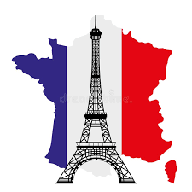 | In French, children will focus on In My French House, learning vocabulary and phrases to describe rooms, furniture, and everyday objects at home. Pupils will practise speaking, listening, reading, and writing skills, using sentences to talk about their own homes and engage in simple conversations in French.

