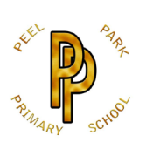 | Peel Park Primary School  Spring Term 2026 Year 3 Curriculum Information

Learning in Year 3 this term:

English | 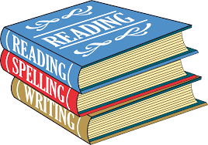 | In the first week of Spring 1, children will take part in Whole School Writing Week with a winter poetry theme. They will then begin their exploration into the focus text: Stone Age Boy by Satoshi Kitamura. Year 3 will be writing a narrative, to entertain Mrs Childs! As we move to Spring 2, our next focus text will be Shackleton’s Journey by William Gill. The children will be writing a balanced argument/debate to persuade, followed by a setting description to entertain.
Maths | 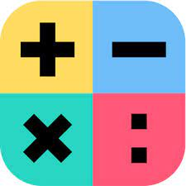 | During Spring 1, Year 3 will continue their work on multiplication and division, before moving on to study measurement: length and perimeter. As we move to Spring 2, Year 3 will begin their first fractions unit. This will then be followed by measurement: mass and capacity.
Science |  | In Spring 1 we will be learning about fossils and soils, and by the end of the unit, children should be able to answer the question, ‘What are fossils and where did they come from?’.  In Spring 2, Year 3 scientists will be researching light. We will also be answering the question, ‘What are different light sources and how do shadows form?’
Computing |  | During Spring 1, Year 3 will completed their first programming unit: sequencing sounds. We will then have an E-safety week. As we move to Spring 2, the children will be exploring data and information: branching databases.
History |  | Our History unit will be taught in Autumn 1, exploring the Romans and seeking to answer the question ‘Why did the Romans invade and settle in Britain?’  After half term, we will host Remembrance Week and explore the question ‘How do we remember the war?
Geography |  | Our Geography unit will be taught in Spring 1 and we will be answering the question, ‘Would you prefer to have lived in the Stone Age, Bronze Age or Iron Age?’ It is great that this directly links to our English text!
Art | 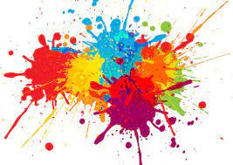 | Art will be taught in Spring 1 of this term. The children will be completing a painting and mixed media unit: prehistoric painting.
DT |  | DT will be taught in Spring 2 of this term. They will take part in a cooking and nutrition unit: eating seasonally.
PE |  | In Spring 1, our Indoor PE unit will be dance, Rock and Roll, which directly links to our science learning.
PSHE | 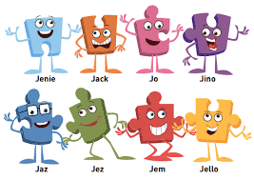 | In Spring 1, our topic is ‘Dreams and Goals.’  In Spring 2, our topic is ‘Healthy Me’.
Religion and Worldviews |  | RE will be taught in Spring 1 of this term. The children will be exploring the question ‘Where do our morals come from?’
Music |  | Music will be taught in Spring 1 of this term. Children will be learning about pentatonic melodies and composition, with a focus on Chinese New Year.
French | 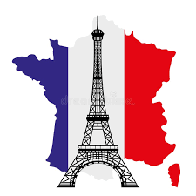 | French will be taught in Spring 2 of this term. The children will learn about and use French adjectives of size, colour and shape.
Homework | 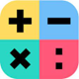  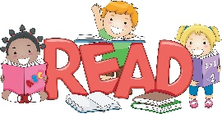 | In Year 3, we ask children to complete a minimum of three games per week on Spelling Shed (via EdShed). They can also practice the spelling words using the spelling list on our homework sheet; this will be sent home on a Friday afternoon weekly. They should also read with an adult at least three times a week and record this in their reading record. Times tables practice is to be completed weekly on TT Rockstars, and children should look out for any battles or challenges set by their class teacher. All logins for EdShed and TT Rockstars can be found on the inside front cover of your child’s reading record.

