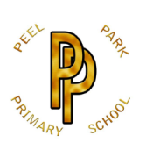 | Peel Park Primary School  Spring Term 2026 Year 1 Curriculum Information

Learning in Year 1 this term:

English | 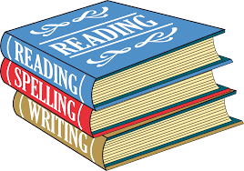 | Text = Lost in the Toy Museum: an adventure  Our purpose = Writing to inform (diary and non-chronological report)  Our focus = To use capital letters, finger spaces and full stops and to sequence events in the correct order using time words (first, next, then and finally).  Text = A Walk in the Woods  Our purpose = Writing to Entertain and writing to persuade (setting description and letter).  Our focus = To use conjunctions ‘and’ and ‘because’ and using adjectives to develop vocabulary.
Maths | 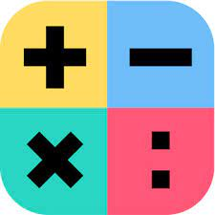 | Number  Addition and Subtraction (within 20)  Place Value (within 50)  Multiples of 2, 5 and 10  Measurement (length, height, mass and volume)
Science |  | What are the needs of plants?  How are animals different?  What can I do to take care of the planet?  What changes happen in different seasons?
Computing |  | E-Safety and programming – making a robot.  Data and information – grouping data.
History | 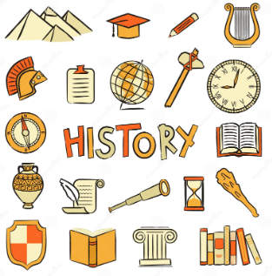 | How have toys changed?
Geography | 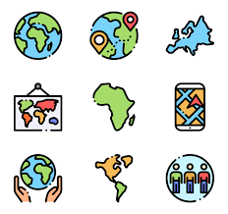 | What is the weather like in the UK?
Art | 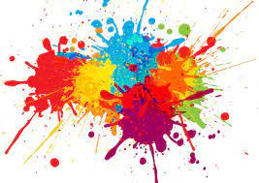 | Painting and mixed media – Colour Splash (Artists – Clarice Cliff and Jasper Jones).
DT |  | Textiles – making puppets.
PE | 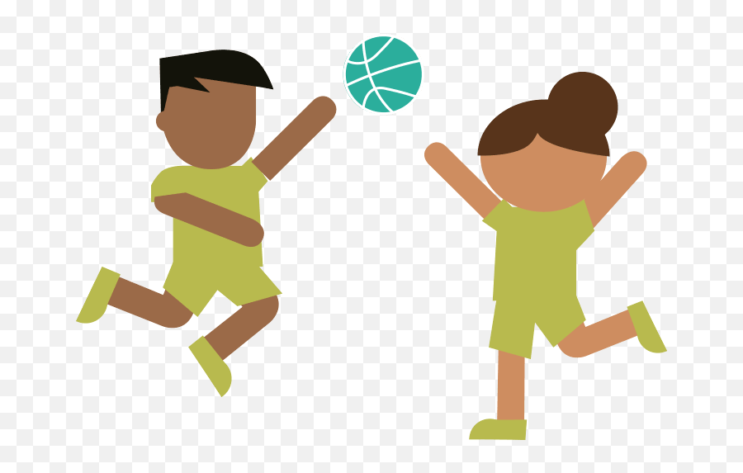 | Indoor dance – animals  Fundamental Movement Skills – Overarm throw  Tri-Throlf
PSHE | 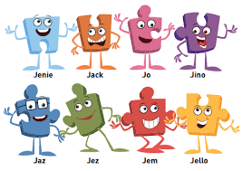 | Dreams and Goals  Healthy Me
Religion and World Views |  | What do some people believe God looks like?
Music |  | Sound Movements - Fairytales
Reading | 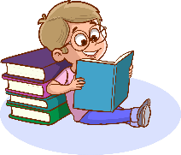 | Your child will read to an adult at least once per week on the same day, this is when the home readers will be changed. Please read with your child 3 times a week and sign their reading record.
Homework | 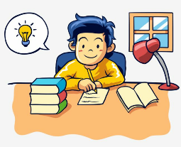 | Homework will alternate between maths and English and will be sent home on a Monday every week.

